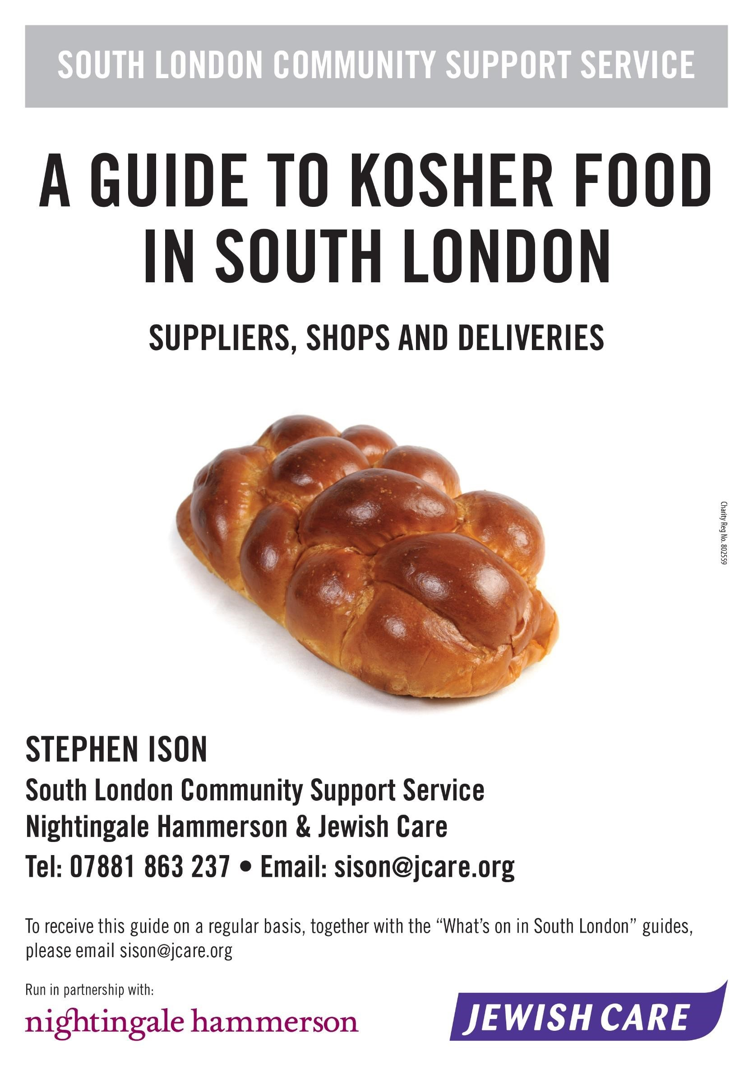

It cannot be guaranteed that all information contained in this document is up to date or correct, so please check with the supplier first before travelling long distances. Please also update me with information you feel would be helpful to others.

Bella Del Gelato – Maison Artisanal
The ice cream (apart from Oreo biscuit flavour) and all sorbets sold are kosher under a license provided by the Sephardi Beth Din. Please be aware that this does not cover toppings, cones, cakes and waffles etc.
343 Upper Richmond Road, London, SW14 8QN (5 minute walk from Mortlake Station) Email: belladelgelato@yahoo.co.uk Website: www.belladelgelato.com

Opening times
Weekdays 8.00am–8.00pm Sunday 8.30am–8.00pm

Nightingale Garden Café (kosher but does not hold kashrut license)
Overlooking gardens, this café serves a variety of deli-style foods as well as tea, coffee and cakes.
Located on the ground floor of Nightingale at 105 Nightingale Lane, London SW12 8NB Telephone: 020 8673 3495

Opening times
Monday to Thursday 10.00am–4.30pm
Friday 10.00am–3.30pm
Sunday 10.00am– 5.00pm
Closed on Saturdays, Jewish holy days and some bank holidays

Kosher Bread (and some bread products) now provided by Hovis, Kingsmill and Buckingham Boulangerie
Hovis: The US’ London Beth Din Kashrut Division (KLBD) are supervising now many of the breads provided by Hovis but need to check that the product bears the KLBD logo – British Farmers White, Farmhouse Wholemeal, Good Inside Best of Both, Good Inside Soft White,
Good Inside Wholemeal, Granary Original, Granary Wholemeal, Nimble Malted
Wholegrain, Nimble Wholemeal, Seed Sensations 7 Seeds Original, Seed Sensations 7 Seeds
Wholemeal, Seed Sensations Chia, Soft White, Sunflower & Pumpkin Seed & Wholemeal.
Buckingham Boulangerie (stocked by 200 Waitrose stores) stock challah and sliced rye from. The loaves from Buckingham’s now proudly display a KLBD logo, marking their challah and sliced rye as kosher to the very highest standards (Pat Yisrael). Rabbi Jeremy Conway, KLBD Kashrut Director commented, “More varieties of KLBD certified bread are set to follow with distribution through an even greater number of outlets.
The Federation Beth Din now supervise many Kingsmill sliced loaves and also crumpets, waffles, pancakes and sandwich thins.
Kosher Sandwiches and Salads from 1701 Kitchen are available from AMT Coffee Shops across South London.

Goldsmiths University | Dixon Road, New Cross, London, SE14 6NW | 020 7919 7171
Kings College London Boland House | St Thomas Street, London, SE1 9RT | -
Sainsbury's  Brompton Road | Moreau House, 112-120 Brompton Road, London, SW3 1JJ | 020 7584 6939
Sainsbury's  Clapham High Street | 33 Clapham High Street, London, SW4 7TP | 020 7622 8637
Sainsbury's Croydon | 59 High Street, Croydon, CR0 1OD | 020 8918 8140
Sainsbury's Dulwich | 80 Dog Kennel Lane, London, SE22 8BB | 020 7738 4900
Sainsbury's  Kensington High Street | 346 Kensington High Street, Kensington, London,  W14 8NS | 020 7371 3514
Sainsbury's  Lambeth Brixton Station | 425 Brixton Road, London, SW9 8HE | 020 7274 1557
Sainsbury's Tooting Bec | 43 Tooting Bec, London, SW17 8BS | 020 8506 4953
Sainsbury's  Waterloo Local | 101 Waterloo Road, SE1 8UL | 020 7401 3823
Whistlestop  Waterloo Station | Platform 1, Waterloo Rail Station, London, SE1 8SE | 020 7928 8182
Whistlestop Food & Wine  Victoria Station | Victoria Concourse, British Rail Station, London,  SW1V 1JU | 020 7976 5533

It is worth contacting your local authority to find out about kosher meals on wheels.
If you want to know about hospital kosher meals, please contact me as they can be made available at any hospital in the M25. Deliveries can usually be set up within 24 hours.

Israeli Food Direct
A service based in South East London providing an online kosher superstore. They deliver Sunday to Thursday and have a list of over 1,800 products including fresh bakery, kosher meat, poultry, wine and groceries.
Telephone: 07960 173625 Website: www.israelifooddirect.com

Just Kosher (formally Goldberg Kosher Butchers)
They offer a full range of meat and poultry, deli products, dry goods and fresh bread.
Delivery is normally free for all orders over £30, and they deliver to home. All orders are COD or can pay prior to delivery over the phone using debit/credit cards. Deliveries to South London once every 4 weeks. Areas covered include Bromley, Catford, Croydon, Beckenham, Sutton, areas in between and as far as Epsom.
Telephone: 0208 551 2828 Email: info@justkosher.co.uk Website: www.justkosher.co.uk

M. Lipowitz Kosher Butcher
Royal Parade, Ealing, London W5 1ET Telephone: 020 8997 1722

Wiltshire Farm Foods
Offering London Beth Din supervised meals. Specify you are interested in kosher meals. Telephone: 0800 773 773

La Boucherie
Free delivery to all areas of South London on Tuesday for orders of £50 or over. Smaller orders can be considered by negotiation. Various meats, salad, chicken delivered. Can also cater for special occasions.
Telephone: 020 8551 9215

Hermolis
Telephone: 020 8810 4321 Email: sales@hermolis.com Website: www.hermolis.com

Kosher Deli
Free deliveries to South London on Tuesdays. Also delivers to South London Synagogue in Streatham once a month on a Wednesday (for collection by members on that day or soon after). Minimum order of £25 or less by negotiation.
Telephone: 0208 381 4450
OCCASIONAL – We suggest you contact your local synagogue at major festival times, such as Pesach and Rosh Hashonah as some of them have deliveries from other distributors. For example, LEWCO which is a Manchester based firm that has recently started to deliver.
Ocado
Search for “kosher” on the website to get a full list of products. Delivery charges vary depending on times chosen and minimum order £40.
Website: www.ocado.com

Sainsbury’s
Search for “kosher” on the website to get a full list of products.
Website: www.sainsburystoyou.com Telephone shopping service: 0800 3281700
Sainsbury’s are the only large supermarket to offer telephone shopping. The phone line is open during the following times:
Monday to Friday 8.00am–9.00pm
Saturday 8.00am–8.30pm Sunday 10.00am–6.30pm

Tesco
Website: www.tesco.com

Beckenham Junction
Waitrose
Stocks a lot of kosher food including frozen goods such as Yarden turkey schnitzels and frozen whole chickens. Often have fresh meat but worth phoning first to check their stock. Beckenham, Elders End
Tesco
At the moment they have fair range of chilled and dry goods and may stock frozen food.

Bromley South
Waitrose
Good stock of kosher food as above.

Cobham
Waitrose
Good stock of kosher food as above.

Clapham Junction
Asda
This store has a good range including wine.

Croydon
Costco
Small but regularly restocked kosher items include challah, rye bread, Gilberts chopped liver and salt beef, Blooms meat products, Orkney Foods herrings, Great Food fishballs, falafel, and salmon batons, and New Green cucumbers. Membership is required. Kingston
Sainsbury’s
Sells Kiddush wine.
Kingston Market
Food for Thought and Surbiton Whole Foods sell the Tivall vegetarian food range.

Lee Green
Sainsbury’s (Burnt Ash Road)
This store has dry goods and a freezer section. The freezer section is quite a good size and includes Mendelssohn’s pizza, bagel pizzas, Yarden products (schnitzel, nuggets, latkes etc.), fish fingers and Tivall vegetarian products.

New Malden
Tesco
Kosher products are clearly marked within the World Foods section. They have candles, memorial lights, and grocery products by Manischewitz, Gefen, Osem, Telma, Mrs Elswood, and Rumpler, in addition to at least half a dozen kosher wines.

Purley
Tesco
A range of dried goods and kosher wine.

Richmond
Waitrose
A good range of kosher food and some dry goods. In the chilled section they are stocking herring, chopped herring, tuna bites, and fish balls, lockshen pudding, salmon fishcakes, hummus, chrane, latkes, paprika beef, various dips, cheese, smoked salmon and more. Also assorted packets of cold meats such as pastrami, turkey, and chopped liver, liver sausage, wursht, viennas, cocktail viennas and more. They are also stocking Gilbert’s fresh meats including pickled brisket, minced beef, steaks and joints. Dry goods include candles, memorial candles, biscuits and soup powders. Frozen chicken pieces and whole chickens have been requested. Roehampton
Asda (on the A3)
Sells Kiddush wine and dinner wine. Asda also sells Carmel Valley red and white.

Southwark
Asda, Old Kent Road
This store has some frozen goods.

Streatham
Korona Delicatessen
Stocks packaged kosher foods and dry goods. Also stocks some deli items but care needs to be taken to check they are kosher as opposed to kosher style.
30 Streatham High Road, Streatham, London SW16 1DB Telephone: 020 8769 6647

Streatham Common
Sainsbury’s
Stocks a selection of dry kosher goods.

Surbiton
Sainsbury’s (Victoria Road)
Supplies a range of kosher food including Osem soups and cakes, grape juice, Kiddush wine, Tivall vegetarian foods, Telma soup cubes and noodles, pickles, dips, and meat products such as viennas, sausages, cold meats, and Gilberts Chopped Liver.

Sutton
Morrisons
Kosher section within World Foods aisle has packaged Osem and Rakusen products including cakes, biscuits, and matza meal, plus Barkan red kosher wine.
S. R. Kay & Son
Fishmonger in St Nicholas Centre has packs of kosher smoked salmon.
Holland & Barratt Sells Tivall Products.

Sydenham
Sainsbury’s
This store sells Yarden products, frozen chicken (whole and pieces), sausages, fish balls, etc. They also usually stock Tomor margarine (hard and soft)!

Vauxhall
Sainsbury’s
This store has a selection of dried goods and prepacked meats such as viennas and salami, as well as chopped liver and gefilte fish balls.

Wimbledon
Waitrose (Alexandra Road)
This store is now stocking a full range of Israeli and kosher food in chilled and ambient sections as well as some Buckingham Boulangerie bread lines (400g rye and 400g Cholla). This shop is also grateful for suggestions which should be made to Vicky Gilder Departmental Manager Retail at 0208 947 9619 or Managerwimbledon@waitrose.co.uk.

West Wimbledon
Tony’s
This store sells a range of kosher produce including Osem soups and cakes, dinner wine, Kiddush wine, Telma soup cubes and noodles, pickles, dips and meat products. Challahs are available every Thursday.
348 Coombe Lane, London, SW20 ORJ Telephone: 020 8241 0442

Across London
AMT Coffee
One can enjoy fresh sandwiches and salads celebrating Jewish cuisine in a number of locations across London.
To discuss how they might supply your business, call 020 7624 2013 or 020 8376 5975.
DD’s
DD's kosher sandwiches offer a variety of over 60 tastily filled traditional and specialty bread sandwiches to over 80 stores throughout London.
Locations available on the website: www.koshersandwiches.co.uk

Nightingale Shop
Good selection of kosher sweets, chocolates, cakes and Jewish greetings cards. Also Chanukah candles, yahrzeit candles and some menorahs for sale.
Nightingale, 105 Nightingale Lane, London SW12 8NB Telephone 020 8673 3495 Opening times
Sunday to Thursday 1.30pm – 4.00pm
Fridays 10.00am – 12.00pm
Closed Saturdays, Jewish Holy Days and Bank Holidays
The Kosher Corner and Bookshop at Chabad House (Wimbledon) A range of food and drink including (but not limited to):
Frozen challot, bread, chicken, meat, biscuits, yahrzeit candles, Shabbat candles, cheeses, chrayne, gefilte fish, matzo meal, wines, grape juice, pickles, olives, cakes, etc.
Judaica including:
Artscroll siddurim, chumashim, a full line of Jewish books, CDs, Mezuzah cases and Mezuzahs, chanukiyot, kippot, taleisim, etc.

Opening times
Tuesday 12.00pm – 1.00pm
Wednesday 9.30pm – 10.30pm
Friday 11.00am – 1.00pm
Other times by appointment. Telephone: 020 944 1581
The Judaica Shop (not food!) at North West Surrey Synagogue Candles, Gifts, Cards and Books.
Open Sunday 10.00am – 12.30pm Telephone: 01483 823898
Kosher Outlet
This is a large discount supermarket based in Hendon, North West London sells kosher food and meat as well other items of interest to the kosher consumer at substantial discounts ranging between 20-30%. They are a 5 minute drive from Hendon Central with ample off street parking.
Pentavia Retail Park, Watford Way, London, NW7 2ET Telephone: 0203 519 0777
Email: info@kosheroutlet.org Website: www.kosheroutlet.org

Opening times
Monday and Tuesday 9.00am – 8.00pm
Wednesday and Thursday 9.00am – 10.00pm
Friday 9.00am – 1.00pm
Closed Saturday
Sunday 10.00am – 8.00pm

Newspapers
The Jewish Chronicle - This is not exactly food but it might be “food for thought” if you want to try and buy a Jewish Chronicle local to you. If you look on the website
retailfinder.magcafe.com then type in the name of the newspaper (Jewish Chronicle) and your south London post code and it lists all stockists (the list that appears on the left side). Unfortunately, we nor the JC can guarantee that stockist definitely has it every week, or whether it means they receive some pre-ordered but it is certainly worth a try!
The Jewish News - The JN (a free newspaper) is now available every week at Nightingale
House and in many synagogues. It is also available online via www.jewishnews.co.uk

