contents
Our Vision 2
Term Dates 2020-2021 3
Timetable 3
Class Aallocations 4
Four stages in Cheder 5-6
Who’s Who at the Cheder 7
What we teach at the Cheder 7
Message from the Head Teacher 8
Also for parents during Cheder 9
Services for Families 9
General Information for the parents 10-12
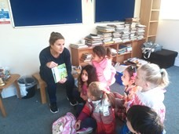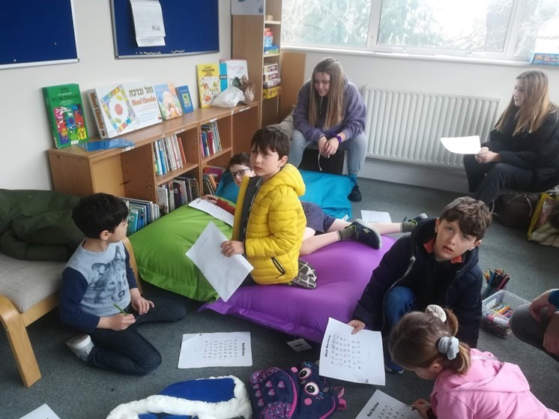
Enjoying the Cheder library

Our Vision
At Wimbledon Cheder we expose the students to Jewish history, religious stories, beliefs, festivals and practices in a safe learning environment so that they will have the motivation and the ability to develop their own Jewish identity. Our fantastic team of dedicated teachers challenge and inspire the children to discover their Jewish identity. Through dynamic and creative lessons the students identify aspects of their own experience and feelings, and what they find interesting and of value and concern to themselves.
Our main goal is providing the students with a safe and caring place where they can meet each week and develop sense of belonging to the local Jewish community, to the Jews in the Land of Israel as well as to the Jewish people around the world. Hopefully this feeling of belonging will create sense of responsibility within family, community, and the world.
We believe that the best way to develop a strong Jewish identity is in an open environment that encourages tolerance and acceptance, and therefore we attach great importance to the
value of interfaith in our school.
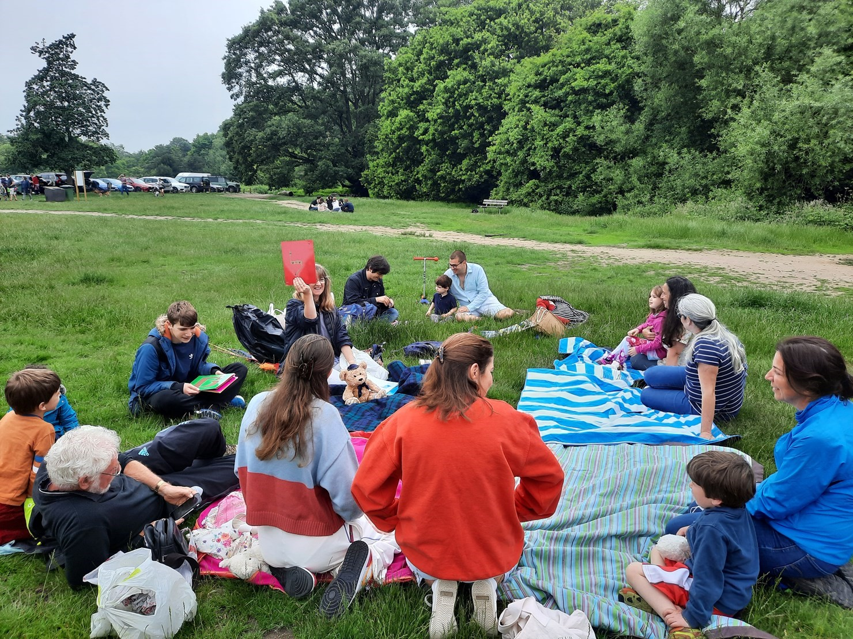
Last day of the Zoom Cheder—a chance teachers and children to meet on the Common

Timetable
Our Religion School meets on Sundays from 10.00am to 12.30pm at the Wimbledon Synagogue, 1 Queensmere Road, London SW19 5QD.

The Religion School year follows that of secular schools with Sukkot (Autumn), Purim (Spring) and Shavuot (Summer) terms.

Cheder starts punctually at 10.00am and finishes at 12.30pm.

Please make every effort to bring your child on time and to collect them promptly at the front door of the school. Children in the Gan, Aleph and Bet classes should be taken directly to and collected from their classroom at the end of the morning.

At 10.00am you are welcome to join us for Havdalah,the separation of Shabbat from the rest of the week which is followed by the weekly assemblies before the children head off to their classrooms.

Each week, children have a 15 minute break where they can have a snack, play or just relax. Unless it is raining, students are required to be outside. Please make sure your child dresses appropriately for the weather.

Bagels and juice provided by the PTA can be purchased during snack time. It is a good idea to send your child to Cheder with a labelled water bottle in hot weather.
A typical Sunday schedule
10:00 Havdalah & Assemblies
10.30 Session 1
11:20 BREAK
11:40: Session 2
12:30 End of Cheder

CLASS ALLOCATIONS 2021-2022
DATE OF BIRTH
CLASS |  | FOR ENTRY
PLAYSHUL |  | _{Early Years} After Sept 17
GAN |  | _{Reception} Between Sept 2016 – Aug 2017
ALEF |  | Year 1 | Between Sept 2015 – Aug 2016
BET |  | Year 2 | Between Sept 2014 & Aug 2015
GIMEL |  | Year 3 | Between Sept 2013 & Aug 2014
DALET |  | Year 4 | Between Sept 2012 & Aug 2013
HAY |  | Year 5 | Between Sept 2011 & Aug 2012
VAV |  | Year 6 | Between Sept 2010 & Aug 2011
BRIYAH | Bar Mitzvah  1 | Year 7 | Between Sept 2009 & Aug 2010
EMUNAH | Bar Mitzvah  2 | Year 8 | Between Sept 2008 & Aug 2009
RE’UT | GCSE 1 | Year 9 | Between Sept 2007 & Aug 2008
ATID | GCSE 11 | Year 10 | Between Sept 2006 & Aug 2007
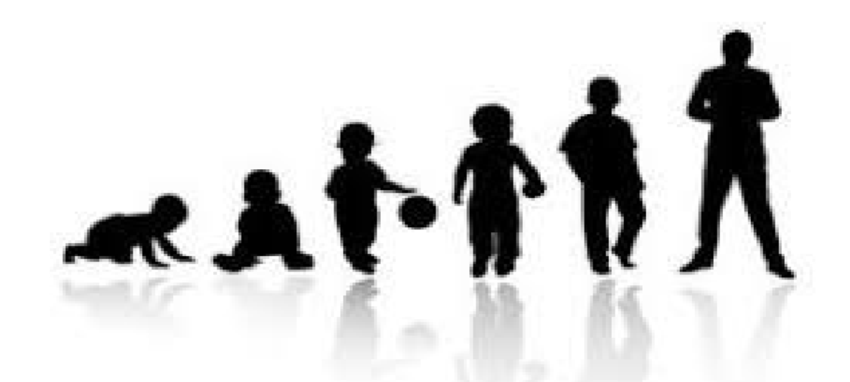

Four stages in Cheder

(1) Playshul
Playshul is a pre-Cheder programme for children aged 0-4 and their families. Through activities including arts and crafts, construction, cookery, singing and dancing, we follow the calendar of the Jewish year. There is a soft play area where babies can safely enjoy Jewish family time and a professionally designed outdoor play area for pre-school children.
Playshul is for children and parents to enjoy interactive Jewish learning together in a stimulating , welcoming and fun educational environment. Parents are expected to remain with their children for the duration of the morning.
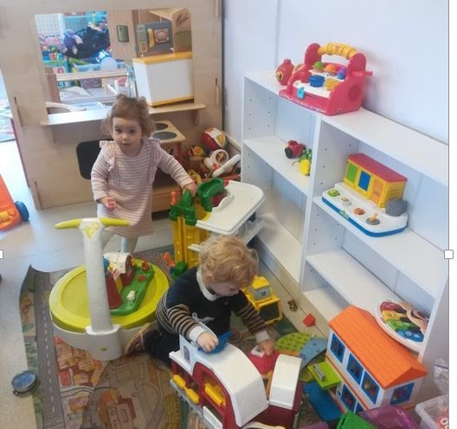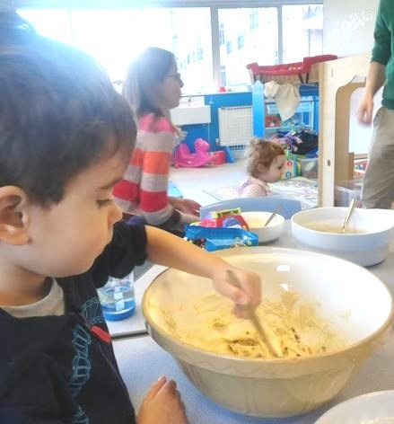

(2) Gan through Vav
Through a range of learning methods including classroom activities, guest speakers and field trips, the children in the Gan (Reception) - Vav (Year 6) classes look at all aspects of Jewish life. At this stage, the children acquire the basics of Hebrew language studies.
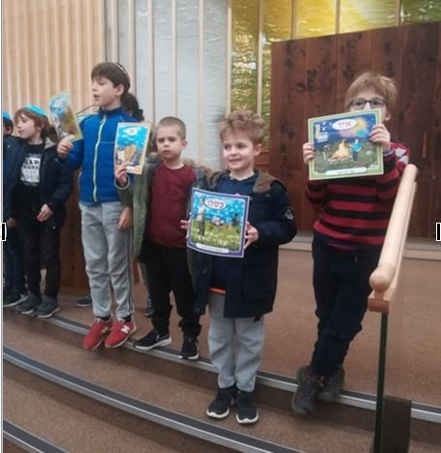

(3) B’nei Mitzvah stage: Briyah and Emunah
In the Briyah (Year 7 – Emunah (Year 8) classes leading up to B’nei Mitzvah, the children focus on the diversity of Jewish life and what it means to be Jewish in a non-Jewish world. This course of study will ensure that every child is prepared to become a Jewish adult in the community. The curriculum is based on 6 strands:
A major part of the B’nei Mitzvah preparation takes place at Cheder so children are expected to be regular attendees and, indeed, to continue to the end of the academic year regardless of the month in which their Bar / Bat Mitzvah ceremony takes place. They may then continue their involvement in Jewish education by taking the the new Post B’Nei Mitzvah course.

During the course of the B’nei Mitzvah year, pupils prepare for and lead a Friday night and Saturday morning service as a group. They and their families also participate in a programme of meetings and meals with the Rabbi following Shabbat services. These pupils are expected to regularly attend Shabbat services, including but not limited to their peers’ B’nei Mitzvah.

(4) Post B’nei Mitzvah stage: Re’ut and Atid
The Re’ut (year 9) and Atid (year 10) classes are the final years of Cheder, and also of our bespoke Judaism and Ethics for Teens Programme (JET).
The mission of this two-year course is to equip our teens with the Jewish knowledge and skills to:
- fully participate competently in Jewish life,
- make ethical choices, and
- serve as effective assistants in the Wimbledon Synagogue Cheder.

In the first year of the programme (Re’ut class), students studied Judaism and Jewish practice. Atid is the ethics class, and we have spirited discussions grappling with Jewish perspectives on topics like body ethics, the environment, wealth, conflict, and crime and punishment. In our conversations we also explore different ways of engaging with Judaism, including text, practice, mussar (ethics and character), spirituality and mysticism (with an introduction to Kabbalah), tikkun olam (social justice), and the creative approaches of midrash.
We participate in our community, learning how to create social justice programmes and completing a class project in support of the Synagogue Night Shelter. Students explore their own thinking, their family background, and the opinions of other Jews through Individual and group projects, building leadership and communication skills along the way. Finally, teacher training will prepare students to come back as assistants if they wish in the autumn.
* Students who complete all of the requirements of the course will be eligible to become assistants, and will also receive an official award certificate from Leo Baeck College, presented by Dr.
Jo-Ann Meyers, Director of Jewish Education and our external examiner.

Who’s Who at the Cheder
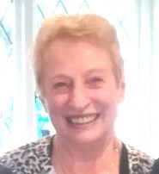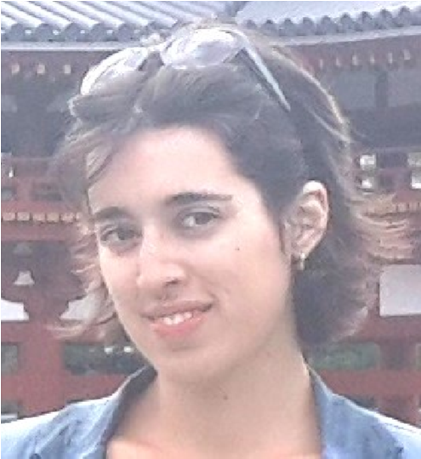

Head Teacher: Julia Stolyar Administrator: Diane Barnett headteacher@wimshul.org
cheder@wimshul.org

What we teach at the Cheder
Our curriculum includes:
Bible stories | Faith and prayers
Jewish values, mitzvot and ethics | Jewish lifecycle events and traditions
Jewish calendar and Festivals | Jewish Texts: sources and applications
Jewish history and current events | Israel
Interfaith and tolerance | Hebrew reading and writing skills
In general, we follow the same curriculum for all of our classes; however, when the teachers determining the learning objectives and creating a lesson plan we follow two grounded principles:

Age appropriate teaching: In every age group the teacher will aim for a different level of understanding, implementation and integration with existing old knowledge. As educators we need to consider the mental, emotional and social maturity of a child, rather than choosing an educational path linked only to numerical age.

Active learning: which is an approach based on activities that encourage students to take an active, engaged part in the learning process. By becoming active participants in the classroom, students build knowledge through their own experiences. For teachers, active learning provides more opportunities to interact with students, and for the students with each other. Active learning will include: group discussions, student presentations, experiments, quizzes, problem-solving, roleplay etc.
Creating learning experiences that fit within the developmental parameters of the children’s age will ensure that they enjoy learning

Message from the Head Teacher,
“Much have I learned from my rabbis, even more have I learned from my colleagues, but from my students I have learned more than from anyone else.” (Rabbi Chanina)
For the past two- and a-bit years I have been a Hebrew teacher at Cheder, and this quote epitomised my approach. I have learned from the rabbi, I have learned from my colleagues, and I have learned from my students what it means for them to be Jewish in the UK. Cheder for us all is a place of learning Hebrew and Jewish tradition, but it is also a place of discovery and wonder. A place for asking questions and pondering on answers together. A place of play, of developing a community, of belonging. Of discovering the personal and communal connection to the longstanding Jewish tradition.
The world has changed significantly in the past few months, forcing us to keep social distance from the circles of friends, colleagues, classmates and even family members that we used to meet on a regular basis. Keeping the sense of community, connection, and belonging in the times of isolation became a paramount concern and one of Cheder’s objectives. As a school, we have adapted to the requirements, and our wonderful team of dedicated teachers continued to teach via Zoom, sending materials through email and post, keeping in touch with their students and keeping the students engaged and together.
We are all constantly learning. Come and learn with us.

Learning Hebrew at the Cheder
After a year of building a new Hebrew teaching program, we have developed it to fit the unique needs of our Cheder and community by creating original materials and activities as well as utilising existing ones. We are happy to continue working with it and continue developing it to support and deepen the children’s knowledge and understanding of the language.

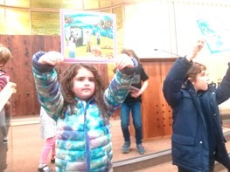

Also for parents during Cheder

Friends of the Cheder (formerly the PTA)
There is a thriving Friends of the Cheder group at the Synagogue Religion School made up of a parent representative from each class and community members. The Committee meets on a regular basis during term time.
One of the most popular events is organising the bagels and coffee during Cheder. Every week fresh bagels direct from London’s East End are prepared by members of the PTA, and they are a delicious addition to the Cheder morning! Parents enjoy sitting in the hall chatting together over a cup of fresh coffee.
The annual Chanukah Fair is a huge fundraiser and enjoyed by the entire community. Parents, children, Cheder staff and community members work together to create a fun morning with opportunities to purchase Judaica for Chanukah (including wrapping paper, cards, table decorations) as well as gifts for all members of your family at varied prices.
The parent representatives work together to support the Religion School, the Education Committee and the teachers, both in terms of providing extra resources through their fundraising activities, and by organising numerous

Services for Families

Shabbat Club
Shabbat Club is held on the fourth Saturday of the month starting at 11am on the first floor of the synagogue building. Shabbat Club is a warm and vibrant family service where we come together to enjoy Shabbat. The services are led by a rota of parents. Children of all ages are welcome (suitable up to 11 years old approximately). Parents, grandparents, aunts, uncles are all welcome to join the fun.
These services complement the children’s Heder studies. The Hebrew they learn and the stories they hear, the songs they sing and the activities they do on Sunday morning are put in context at the Shabbat Club.

Family Services
Services do not come in a one size fits all and every couple of months there is also a shorter family friendly Shabbat morning service for all ages from 0 - 120.

Friday Night Family Services
Young Family Fridays – informal Friday evening services are held quarterly especially for young families followed by a chavurah (shared vegetarian meal) supper. The services are relaxed with prayers, songs and stories. Services start at 6pm and all are welcome.

General Information for the parents

Security
We take security very seriously, particularly in these testing times. We have a security officer, a well-equipped and fully trained security team, and we work closely with the Community Security Trust (CST) and the local Police to ensure our children are safe when attending classes (and at all other times when our Synagogue building is in use).

We expect all parents of children attending Religion School classes to know how our security policies operate in this respect - please see ‘Security Duty at the Religion School’ for more information.

Parking
There is no parking on the Synagogue premises as the area in front of the Synagogue is used by the children during playtime. Parking outside the Synagogue must be on the Synagogue side of the road, even if only dropping off children, to avoid causing problemswith the Synagogue’s neighbours.

Absence
If your child is unwell, he/she should not attend the Cheder until completely better. If he/she has had a temperature, this should be normal for 24 hours before attending Cheder. Please do not let your child attend if he/she has a cold or diarrhoea. Please let your child’s class teacher or the Cheder Administrator cheder@wimshul.org know of any absence in case of illness or of any absence of more than one week.

Mobile Phones
Please ensure your child is aware that use of mobile phones is not allowed in class. If brought to Cheder, phones should remain in school bags and used only in emergencies or if instructed by the class teacher for use with school work, eg. research for a project.

Snacks
Your child will need a snack for break time. Please note that no meat products, meat or trefflavoured products such as prawn flavoured crisps or sweets containing gelatine (eg. Haribo) should be brought in for reasons of kashrut. All store-bought snacks should be clearly labelled as ‘suitable for vegetarians.’ Because of the risk posed to children by nut allergy, all products containing nuts are also banned from the Cheder.

Break time
Please be aware that all pupils must go out of the building for the main break time unless it is raining, in which case a space inside will be designated for them to play. As the weather gets colder, it is vital that they come in with a coat. Please note that the nursery playground is out of bounds to all children except those in Playshul, and the Gan/Aleph/Bet classes.

Tzedakah
Every class collects tzedakah money eacb week for donation to a charity or charities that is/are chosen by the children. We would be grateful if you could send your child with a small coin or coins to put in the class Tzedakah box.in order to teach the importance of charitable giving. We also have a large box in the lobby for dry foods for Merton homeless organisations.

Books
The cost of textbooks is included in the fees but a charge will be made for lost Hebrew books.

Homework
Whilst homework is not usually set until the Emunah (year 8) class, it is difficult for the children to retain and build on what they have learnt without some reinforcement between weekly lessons. Some class teachers will email home worksheets for the children to look at during the week, preferably together with their parents.

Departure/ Pick Up
All children must be collected from inside the Synagogue gates for safety reasons. Gan, Aleph and Bet children should be collected from outside their classrooms.

Lost Property and Equipment
We do not ask children to bring in writing / colouring equipment as so much gets left behind.
Boys are asked to bring a kippah if they have one and girls may also wear a kippah if they wish. All property should be clearly labeled. Lost property can be recovered from the lost property box in the downstairs cloakroom
* Please note that the Wimbledon Synagogue Religion School cannot be responsible for the loss of any valuable item brought to the Religion School by children.

Communication with parents
Every week parents will receive a ‘News from the Cheder’ email as well as an update email from the class teacher. Nitzanim, the Cheder Newsletter, is produced monthly other than in July and August. It is sent with Kehillah, the Synagogue magazine. We welcome contributions from parents and children, and we hope that you will find the information and photos contained in this newsletter interesting and relevant.

* Please note that from time to time the teachers will send other information that requires your response.

Urgent communications and reminders takes place by email so it is important that you inform Diane Barnett of any changes to your email address immediately.

Further information
Please feel free to contact Diane Barnett, the Cheder Administrator, with any queries or concerns on 020 8947 8200 (Monday – Thursday 7.00am – 9.00pm) or email cheder@wimshul.org

Wimbledon School Poli cies
Full Cheder policies covering Anti-Bullying, Behaviour and Child Safeguarding, as well as Health and Safety as it affects the Cheder, can be found on the Synagogue website www.wimshul.org under Education

Wimbledon Synagogue
(a constituent of the Movement for Reform Judaism)
1, Queensmere Road, Off Parkside, London SW19 5QD

Telephone: 020 8946 4836

Fax: 020 8944 7790 email: office@wimshul.org.uk

Cheder email: cheder@wimshul.org

Registered charity: 1150678

